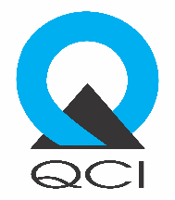

Workplace Assessment for Safety and Hygiene (WASH)
A Scheme by Quality Council of India

FEE STRUCTURE

The following fee structure has been prescribed under the WASH Scheme of QCI:

- Fee for registering under the WASH Scheme as an “Assessment Agency”: NIL
(It may be noted that only NABCB accredited CBs/IBs are eligible to apply)

- Fee to be charged by the registered Assessment Agency for assessment of applicant under WASH Scheme:

  - Rs. 10,500/- (Rupees Ten Thousand and Five Hundred only) + applicable taxes, if the assessment is carried out within 1 man-day.
  - However, for certain workplaces, depending on the size and/or number of employees, it may require additional time (upto another 1 man-day) and the cost of the same may be determined accordingly.
  - The registered assessment Agency may charge the cost of travel/conveyance and stay/accommodation as per the actuals.

- QCI fee to be charged from Assessment Agencies: A consolidated fee of Rs. 500/- will be payable to QCI from the Assessment Agencies, per assessment conducted.

Note:
- The fee payable to QCI will not be charged additionally from the applicant by the Assessment Agency
- GST at rates prescribed by the government would be applicable on all fees.

